# CD LAB 3

NAME: Janvii RV

SRN: PES2UG22CS232

DATE: 20/02/2025

To run the codes, please use the run.sh file.

./run.sh

Input:

1:

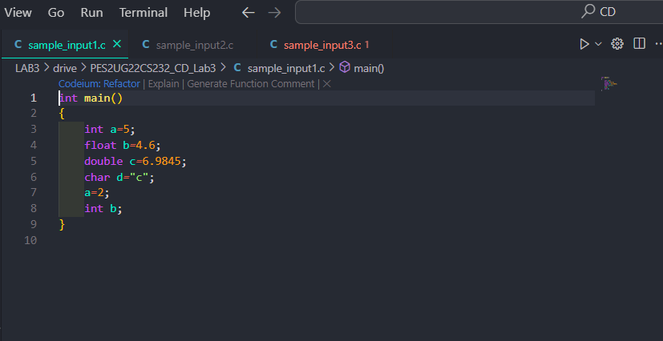

2: 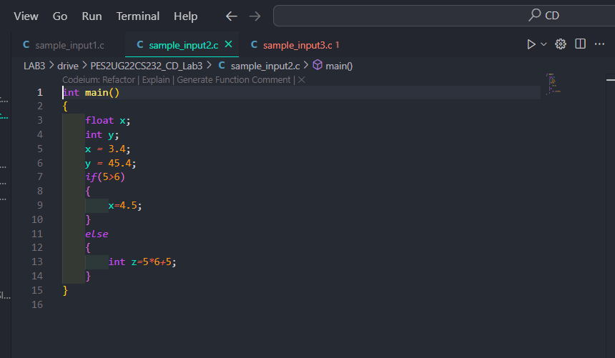

3:

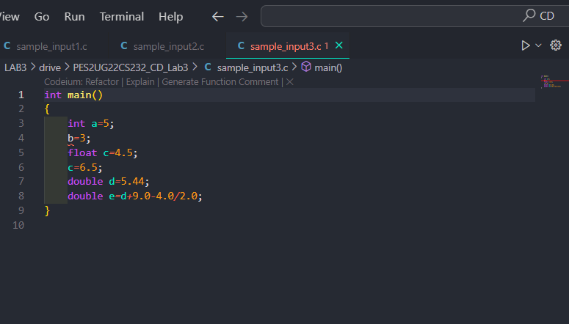

Output Screenshot:

1:

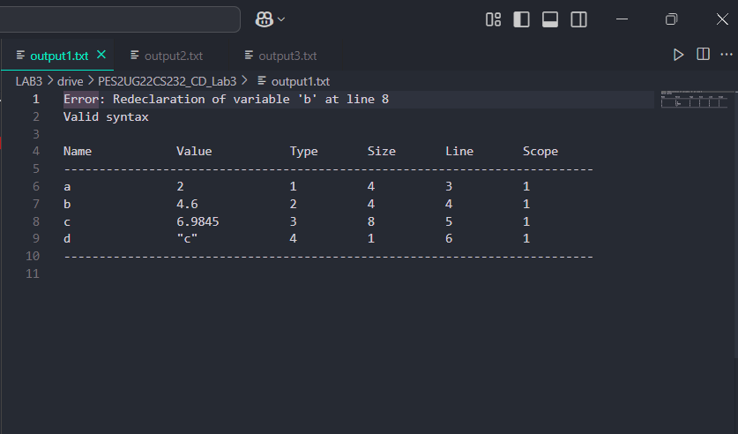

2:

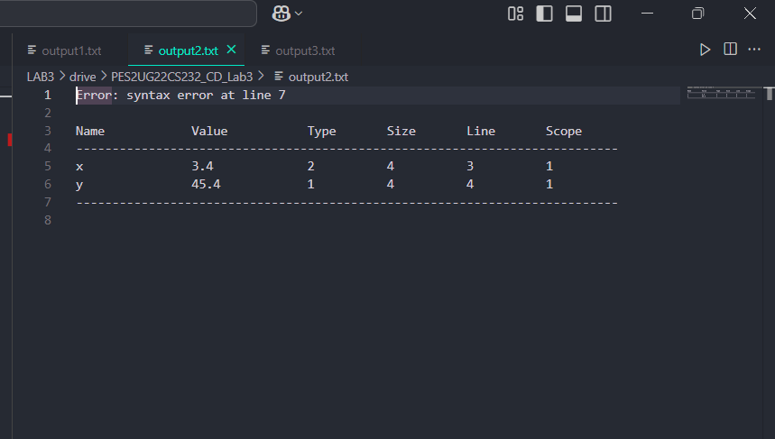

3:

